Function Changes (Reading Mode)

This document is intended to help users transition from UQ Reportal 4.2 to the new UQ Reportal 4.3.
This document provides a guide to locating functions familiar to users from the previous version of UQ Reportal when working on a report in Reading mode in the upgraded environment. It lists the toolbars, contextual menus and explains where each item is in the new UQ Reportal.
If you are looking for a high-level overview of BO 4.3 changes, see the UQ Reportal resources - Overview of Changes.
Design mode: If you are working on reports in Design mode, a UQ Reportal resources - Function Changes (Design Mode) document is available.

Contents

Reading mode toolbar

New
In the File section on the toolbar. You can also create a new report by clicking the Web Intelligence tile from the BI Launch Pad.
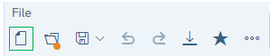

Open
In the File section on the toolbar. Alternatively, from the BI Launch Pad, navigate to the report and open it.
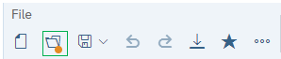

Save/Save As
In the File section of the toolbar. The options are the same, however the layout of the Save As screen has changed.
In the upgraded version, the Save As options into three separate tabs, compared to all options being on one screen. The folder structure and file name fields are on the General tab. The description, key words, and setting checkboxes are on the Options tab. The Assign Categories selection is on the Categories tab.
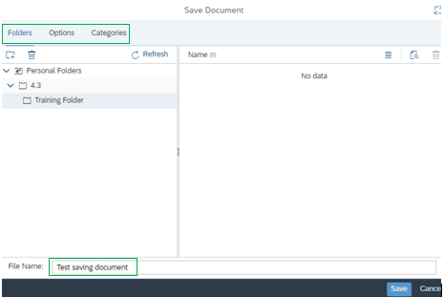

Print
In the File section of the toolbar.
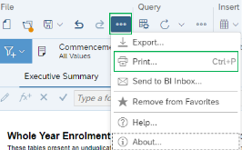

Find
No longer on toolbar. To search the document, use the browser's Find function.

History
No longer on toolbar. To view the history of instances of a document, from the BI Launch Pad, navigate to the document, click the ellipsis on the document tile or row, and select History.
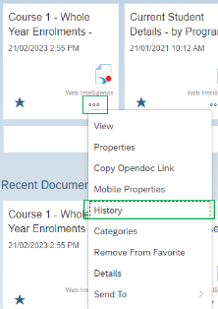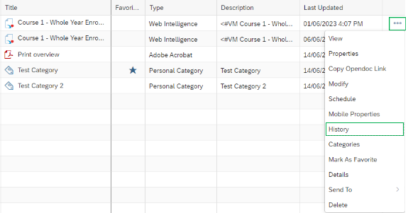

Export
In the File section of the toolbar. The layout of the Export function has changed. All options are now located in the same screen and include exporting to HTML.
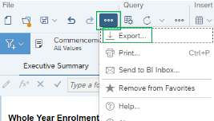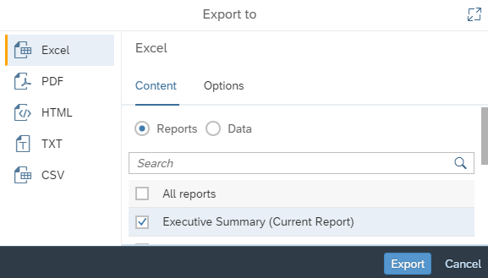

Send To
Send to User is available from the ellipsis in the File section of the toolbar as Send to BI Inbox:
The pop-up screen for sending a report to a user has been redesigned. You search for and select users on the Select Users/Groups tab. As with similar selection screens in the updated version, the move arrows have been replaced with checkboxes. The options for setting a target name and the type of file to send (copy or shortcut) are now on the Send Options tab.
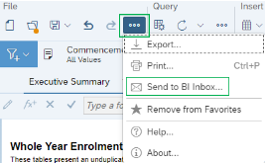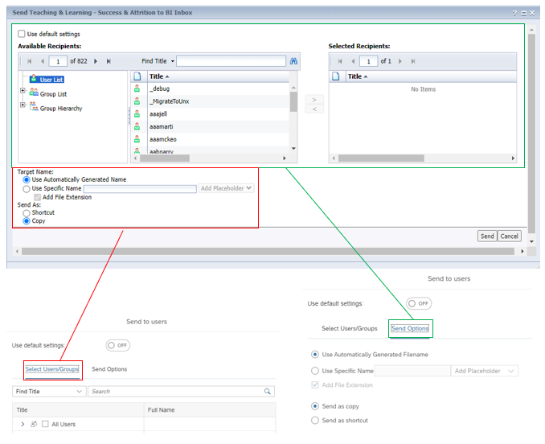

Undo/Redo
In the File section of the toolbar.

Refresh
In the Query section of the toolbar. You can only refresh all, there is no longer an option to refresh individual queries. The Prompts screen that displays (if the report has prompts applied) has the same options but in a different interface.

Below shows the look and feel difference between the 4.2 Prompts window and the 4.3 Prompts window.
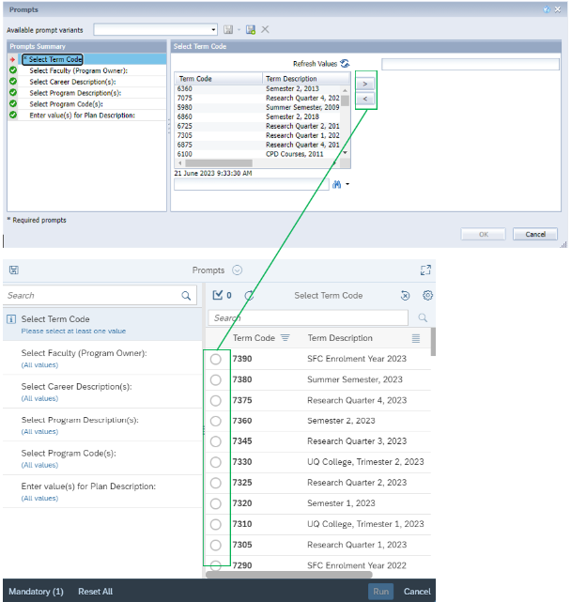

Track
The Show Changes and Track Data Changes icons are in the Analyze section of the toolbar.

Drill
The Drill feature is now called Enable Navigation. It is in the Analyze section of the toolbar and functions the same as it did in 4.2.
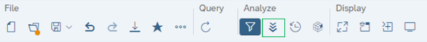

Filter Bar
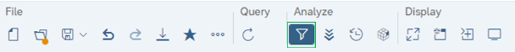
The Filter bar is in the Analyze section of the toolbar. Hiding/Showing the filter bar Collapses/Shows Input controls and filters if they have been applied to a report. If there is a filter on the report, clicking Filter allows you to view a summary of the current prompts used in the report.
As in 4.2, Input controls can only be created in Design mode, use the drill filter function to apply filters in 4.3.

Freeze
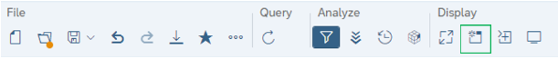
In the Display section of the toolbar and only freezes the headers. To freeze specific columns, right-click on the table and click the Freeze icon that displays to the right of the table.

Outline
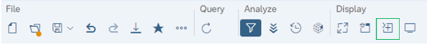

The Outline is now Enable Folding/Unfolding of Breaks and Sections in the Display section. You can click the arrows that display to fold/unfold a report element.
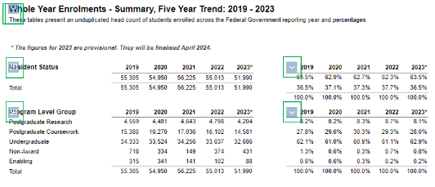

Side panel
In the old version, the left-hand panel includes five functions: Document Summary, Navigation Map, Input Controls, User Prompt Input and Comments.
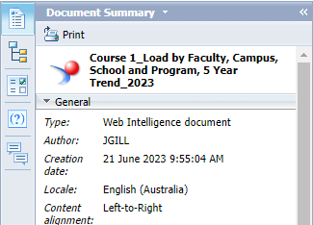
In the new version, it is now the Main Panel and is on the right side. Click the Show Main Panel icon to open the panel.
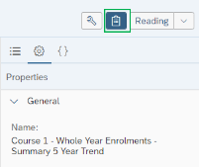

Document Summary
From the Main panel, select Show document properties
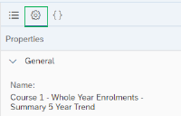
The properties panel has been simplified and there is no longer a Parameters section. The data shown in the Document Options and Data Options sections have been reduced.

Navigation Map
From the Main panel, select Show report map
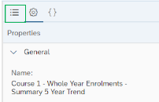
In both versions, the information shown on the panel is the same however how you interact with the panel has changed. Instead of seeing all report tabs at once, you see only the currently selected tab. Now, to drill down into the data, click the arrow next to a value, rather than expanding/collapsing the sections.
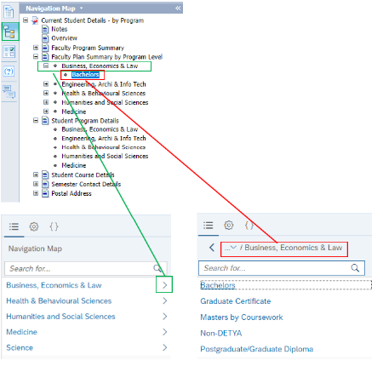

Input Controls
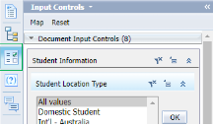
Now available from the under the main toolbar at the top of the page (when the filter bar is expanded). Click on a value to update the selected Input Control. Click Prompt to show the Prompts summary and Reset all input controls to their default value to reset. The Map option has been removed.
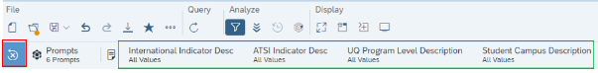
Hover over the icon to the left of the value to see which values are grouped in the Document and Report input controls.
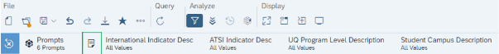
In 4.2, values of Input Controls (depending on format selected) are seen immediately when Input Control panel is open. However, in 4.3, the available values can only be seen once the Input Control is clicked on/expanded, although a limited number of selected values will appear Input Control icon.

User Prompt Input
From the Main panel, select Show prompts
This functionality is not available in 4.3 as it was in 4.2. This section will only provide a summary and you will need to refresh the report to change the prompt values.
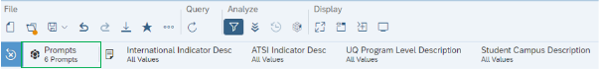
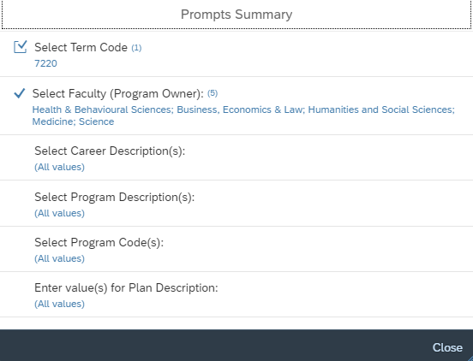

Status bar
The Status Bar displays in 4.3 is dynamic, it displays at the bottom of the screen when your cursor is over the report.

Track changes on/off
Whether or not Track Changes is on is indicated by the Show/Hide Changes icon; if the icon is dark blue, it means changes are being shown.
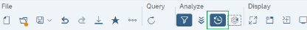

Page Navigation
On the status bar.

Quick display and Page mode
No longer on the status bar. The status bar has options for Show/Hide Print Mode, Fit to Width and Fit to Page.

Zoom
Remains on Status bar. When clicked, the zoom percentage can be changed using a slider.
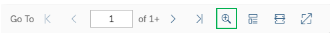

Refresh and Last Refresh time
Click Refresh in the Query section of the main toolbar to refresh the report.
To see when the report was last refreshed, hover over the Refresh icon.
